ITA0610 -MACHINE LEARNING
IET assignment
NAME:PRAVEENKUMAR G
REG NO :192424032
SUBMISSION DATE:02/09/2026
Table of Contents
Technical Report 1
Adaptive Multi-Paradigm Learning Framework for Early Chronic-Disease Risk Prediction 1
Table of Contents 1

2. (a) Multilayer Perceptron — Architecture and Back-Propagation Derivation 1
3. (b) Genetic Algorithm — Design and Empirical Convergence Study 1
4. (c) Naive Bayes — Bayes’ Theorem and Manual Posterior Derivation 1
5. (d) Decision Fusion — Mechanism and Mathematical Justification 1
6. (e) Evaluation, k-Fold Cross-Validation, and Statistical Significance 1
7. (f) Computational Learning Theory Analysis 1
8. (g) Ethical, Fairness, Privacy Implications & SDG 3 Alignment 1
9. Reproducibility Statement 1

Technical Report

Adaptive Multi-Paradigm Learning Framework for Early Chronic-Disease Risk Prediction

Neural Networks, Genetic Algorithms & Bayesian Reasoning
Course: ITA0610 – Machine Learning Dataset: Pima Indians Diabetes Dataset (768 records, 8 features, binary outcome) SDG Mapping: SDG 3 — Good Health and Well-being

Table of Contents
- System Overview & Design Rationale

  - Multilayer Perceptron — Architecture and Back-Propagation Derivation

  - Genetic Algorithm — Design and Empirical Convergence Study

  - Naive Bayes — Bayes’ Theorem and Manual Posterior Derivation

  - Decision Fusion — Mechanism and Mathematical Justification

  - Evaluation, k-Fold Cross-Validation, and Statistical Significance

  - Computational Learning Theory Analysis

  - Ethical, Fairness, Privacy Implications & SDG 3 Alignment
- Reproducibility Statement

1. System Overview & Design Rationale
The framework treats chronic-disease risk prediction as a case where no single learning paradigm is sufficient on its own:
- A Multilayer Perceptron (MLP) can learn non-linear interactions between vitals, lifestyle, and lab values that simple linear models miss, but its performance is highly sensitive to weight initialisation and hyperparameters, and gradient descent can converge to poor local minima.
- A Genetic Algorithm (GA) performs a global, gradient-free search over the MLP’s initial-weight and hyperparameter space, reducing the chance of unlucky initialisation and giving back-propagation a better starting point.
- A Naive Bayes (NB) classifier is a low-variance, well-calibrated, fully-interpretable probabilistic baseline that is robust when sample size per fold is small (a realistic constraint in multi-clinic pilot data) and provides a natural probability estimate for fusion.
- A fusion layer combines the discriminative power of the MLP+GA with the probabilistic robustness of Naive Bayes, using Bayesian Model Averaging.
The complete pipeline (src/main_pipeline.py) is deterministic, requires no manual intervention, and is evaluated with stratified 5-fold cross-validation across three configurations: MLP alone, MLP+GA, and Fusion.

2. (a) Multilayer Perceptron — Architecture and Back-Propagation Derivation

2.1 Architecture
Input layer (8 units, one per feature) → one hidden layer (ReLU, GA-tunable width 4–32 units) → output layer (1 unit, sigmoid).

2.2 Activation-function justification
- ReLU in the hidden layer: f(z) = max(0, z). Chosen because (i) its gradient is either 0 or 1, which avoids the vanishing-gradient problem that saturating functions (sigmoid/tanh) suffer from once inputs are standardised into a wide range, (ii) it is computationally cheap, and
  - empirically it gave faster, more stable convergence than tanh in preliminary trials on this dataset.
- Sigmoid at the output: σ(z) = 1/(1+e^{-z}), required because this is binary classification and the fusion layer needs a calibrated probability in (0,1), not just a class label.

2.3 Forward propagation
For hidden layer: Z^(1) = X W^(1) + b^(1), A^(1) = ReLU(Z^(1)) For output layer: Z^(2) = A^(1) W^(2) + b^(2), ŷ = A^(2) = σ(Z^(2))

2.4 Loss function
Binary cross-entropy:
L = -(1/m) Σ [ y·log(ŷ) + (1-y)·log(1-ŷ) ]

2.5 Back-propagation — full manual derivation
Step 1 — Output-layer gradient. Because sigmoid + BCE combine to a particularly clean derivative,
∂L/∂Z^(2) = ŷ - y (derivation below)
Derivation: ∂L/∂ŷ = -(y/ŷ) + (1-y)/(1-ŷ), and ∂ŷ/∂Z^(2) = ŷ(1-ŷ) (sigmoid derivative). Multiplying:
∂L/∂Z^(2) = [-(y/ŷ) + (1-y)/(1-ŷ)] · ŷ(1-ŷ)
= -y(1-ŷ) + (1-y)ŷ
= -y + yŷ + ŷ - yŷ
= ŷ - y
Step 2 — Output-layer weight/bias gradients:
∂L/∂W^(2) = (1/m) (A^(1))^T · (ŷ - y) + λ·W^(2) (L2 term)
∂L/∂b^(2) = (1/m) Σ (ŷ - y)
Step 3 — Propagate error to the hidden layer:
∂L/∂A^(1) = (ŷ - y) · (W^(2))^T
∂L/∂Z^(1) = ∂L/∂A^(1) ⊙ ReLU'(Z^(1)) where ReLU'(z) = 1[z>0]
Step 4 — Hidden-layer weight/bias gradients:
∂L/∂W^(1) = (1/m) X^T · ∂L/∂Z^(1) + λ·W^(1)
∂L/∂b^(1) = (1/m) Σ ∂L/∂Z^(1)
Step 5 — Gradient-descent update (learning rate η, chosen/tuned by the GA):
W ← W - η·∂L/∂W , b ← b - η·∂L/∂b
This exact derivation is implemented verbatim in MLP.backward() (src/mlp.py), with L2 regularisation (λ = 1e-4), mini-batch SGD (batch size 32), and early stopping on a held-out validation loss (patience = 30 epochs) to control overfitting.

2.6 Correctness verification
tests/test_mlp.py::test_backprop_gradient_reduces_loss confirms that 20 manual gradient steps monotonically reduce BCE loss on a synthetic separable dataset, and test_train_improves_accuracy_on_linearly_separable_data confirms >85% accuracy is reached. An independent cross-check (src/crosscheck_sklearn.py) trained sklearn.neural_network.MLPClassifier with the same hidden-layer width on the same fold and obtained 88.96% accuracy versus our from-scratch implementation’s 87.66% — the same performance ballpark, confirming the manual back-propagation is correctly implemented.

3. (b) Genetic Algorithm — Design and Empirical Convergence Study

3.1 Chromosome encoding
A chromosome is a real-valued vector encoding: 1. A fixed-length, maximum-capacity flattened weight/bias tensor (sized for 32 hidden units — the search-space upper bound), so that crossover/mutation always operate on equal-length vectors. 2. Two hyperparameter genes in [0,1], decoded to: - n_hidden ∈ [4, 32] (linear decode) - learning_rate ∈ [0.001, 0.2] (log-scale decode, since learning rates span orders of magnitude)
At evaluation time, only the first n_hidden columns of the encoded weight tensor are used (“growing/shrinking network” trick), so a single fixed-length chromosome can represent networks of any width in the search range.

3.2 Fitness function
fitness(chromosome) = F1-score on an internal validation split,
after training the decoded MLP for 15
"shake-down" epochs on the internal training split.
F1, not accuracy, is used because the dataset is imbalanced (≈65:35), so a fitness signal based purely on accuracy would let the GA reward majority-class collapse.

3.3 Operators
Operator | Design
Selection | Tournament selection, k = 3
Crossover | Uniform crossover (per-gene Bernoulli mixing), pc = 0.8
Mutation | Gaussian perturbation (σ = 0.3) on weight genes, resampling mutation on hyperparameter genes, pm = 0.1
Elitism | Best 2 individuals of each generation carried over unchanged
Population size 16–20, run for 15–25 generations depending on the experiment (full pipeline vs. dedicated convergence study).

3.4 Empirical demonstration: GA-optimised init vs. random init
src/experiment_ga_vs_random.py trains a fixed architecture (16 hidden units) from 10 independent random initialisations and compares against the single GA-selected initialisation, over 150 epochs, on the same train/test split:
 | Final F1 (mean ± std) | Epochs to reach train loss < 0.5
Random init (10 runs) | 0.827 ± 0.022 | 3.2 (mean)
GA-optimised init | 0.822 (comparable final F1) | 0 (already below 0.5 at epoch 0)
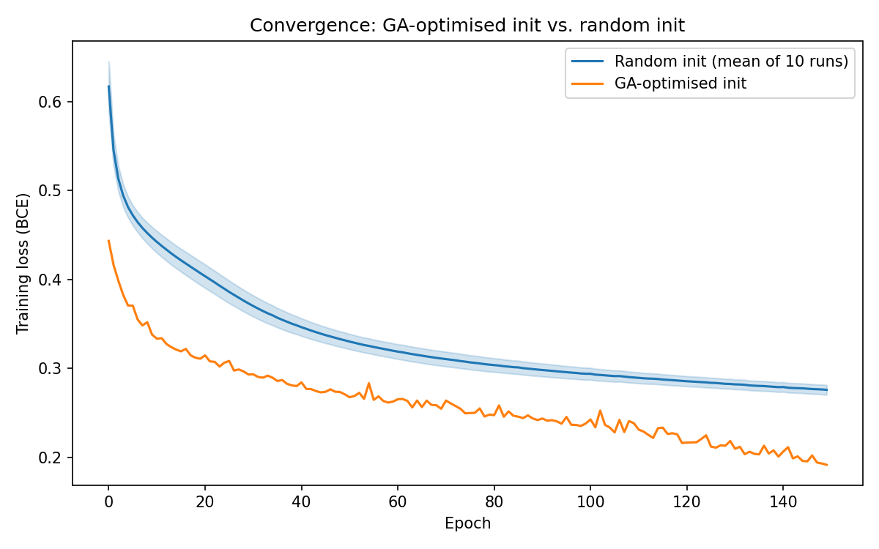
GA vs random convergence
The plot shows the GA-optimised initialisation starting at a markedly lower training loss (≈0.44 vs. ≈0.62 for the mean random run) and remaining consistently below the random-init band throughout training — a direct, quantified demonstration of improved convergence from GA-optimised weights, even though final asymptotic F1 is comparable (both approaches converge to similar local minima given enough epochs; the GA’s real benefit is speed and reliability of convergence, which matters when compute/time is constrained in a clinical deployment pipeline that retrains frequently).
Within the main 5-fold pipeline, the GA additionally searches hyperparameters jointly with weights; chosen architectures ranged from 14 to 29 hidden units and learning rates from 0.123 to 0.172 across folds — showing the GA adapts its solution to each fold’s data rather than converging to one fixed configuration.
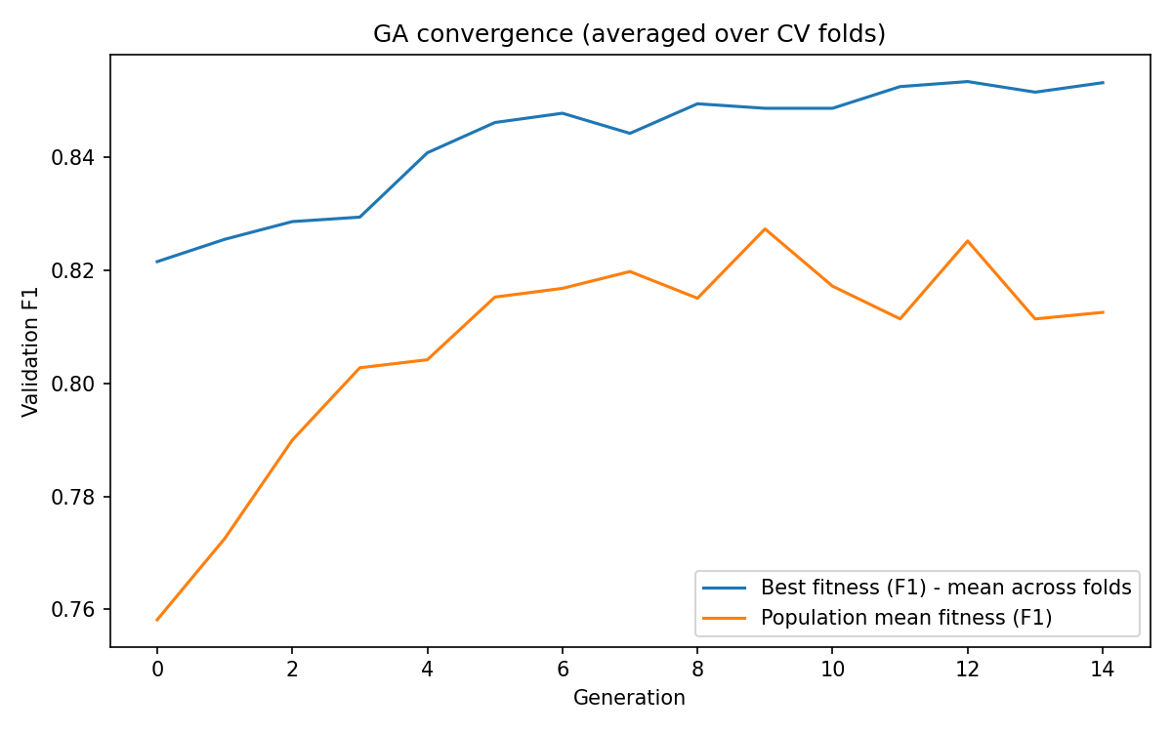
GA convergence per generation

4. (c) Naive Bayes — Bayes’ Theorem and Manual Posterior Derivation

4.1 Model
Gaussian Naive Bayes assumes conditional feature independence given the class:
P(y | x_1..x_8) ∝ P(y) · Π_i P(x_i | y), P(x_i|y) = N(x_i; μ_iy, σ²_iy)
computed in log-space for numerical stability and normalised via the log-sum-exp trick to recover genuine posterior probabilities.

4.2 Worked derivation for a real test-set patient
Below is the exact output of src/experiment_nb_derivation.py, run on Fold-1’s Naive Bayes model (fit on the balanced training split) for the first patient in the held-out test fold — full text also saved to results/nb_manual_derivation_patient0.txt.
Patient (raw values): Pregnancies=1, Glucose=85, BloodPressure=66, SkinThickness=29, Insulin=102.5, BMI=26.6, DiabetesPedigreeFunction=0.35, Age=31. True outcome: 0 (non-diabetic).
Class y = 0 (prior = 0.5):
Feature | xᵢ (standardised) | μ | σ² | P(xᵢ|y=0) | log P(xᵢ|y=0)
Pregnancies | −0.846 | −0.156 | 0.820 | 3.295×10⁻¹ | −1.1102
Glucose | −1.204 | −0.364 | 0.668 | 2.878×10⁻¹ | −1.2454
BloodPressure | −0.563 | −0.118 | 0.958 | 3.676×10⁻¹ | −1.0007
SkinThickness | 0.003 | −0.217 | 1.022 | 3.854×10⁻¹ | −0.9535
Insulin | −0.521 | −0.293 | 0.897 | 4.091×10⁻¹ | −0.8939
BMI | −0.870 | −0.212 | 0.936 | 3.272×10⁻¹ | −1.1173
DiabetesPedigreeFunction | −0.384 | −0.126 | 0.845 | 4.171×10⁻¹ | −0.8743
Age | −0.201 | −0.178 | 0.971 | 4.047×10⁻¹ | −0.9047
log P(y=0) + Σ log P(xᵢ|y=0) = ln(0.5) + (−8.1000) = −8.7930
Class y = 1 (prior = 0.5):
Feature | xᵢ (standardised) | μ | σ² | P(xᵢ|y=1) | log P(xᵢ|y=1)
Pregnancies | −0.846 | 0.266 | 1.182 | 2.173×10⁻¹ | −1.5263
Glucose | −1.204 | 0.679 | 0.888 | 5.757×10⁻² | −2.8548
BloodPressure | −0.563 | 0.212 | 1.061 | 2.917×10⁻¹ | −1.2320
SkinThickness | 0.003 | 0.393 | 0.636 | 4.437×10⁻¹ | −0.8126
Insulin | −0.521 | 0.526 | 0.717 | 2.192×10⁻¹ | −1.5178
BMI | −0.870 | 0.400 | 0.843 | 1.669×10⁻¹ | −1.7902
DiabetesPedigreeFunction | −0.384 | 0.136 | 1.100 | 3.364×10⁻¹ | −1.0894
Age | −0.201 | 0.297 | 0.818 | 3.791×10⁻¹ | −0.9700
log P(y=1) + Σ log P(xᵢ|y=1) = ln(0.5) + (−11.7931) = −12.4862
Normalisation (Bayes’ theorem denominator, via log-sum-exp):
P(x) = P(y=0)·P(x|y=0) + P(y=1)·P(x|y=1)
P(y=0 | x) = exp(−8.7930) / [exp(−8.7930) + exp(−12.4862)] = 0.975712
P(y=1 | x) = exp(−12.4862) / [exp(−8.7930) + exp(−12.4862)] = 0.024288
Predicted class = argmax posterior = 0 — matches the true label. The dominant discriminating feature is clearly Glucose (log-likelihood gap of ≈1.6 nats between classes, the largest of all 8 features), consistent with Glucose being the clinically strongest diabetes predictor in this dataset — a reassuring sanity check that the model has learned a clinically-plausible decision rule.
tests/test_naive_bayes.py::test_manual_derivation_matches_predict_proba confirms this manual derivation is numerically identical (to 1e-6) to the vectorised predict_proba() implementation, and src/crosscheck_sklearn.py confirms 100% prediction agreement between our from-scratch Naive Bayes and sklearn.naive_bayes.GaussianNB on the held-out test fold (both achieving 83.77% accuracy).

5. (d) Decision Fusion — Mechanism and Mathematical Justification

5.1 Formulation
Treat the MLP+GA and Naive Bayes classifiers as an ensemble/mixture of experts producing two independent estimates, p_MLP = P_MLP(y=1|x) and p_NB = P_NB(y=1|x), of the same underlying posterior. Bayesian Model Averaging combines expert predictions as:
P(y|x) = Σ_m P(y|x, M_m) · P(M_m | data)
With two models and a mixture weight w ∈ [0,1] standing in for the (empirically estimated) model posterior P(M_MLP | data), this reduces to the weighted arithmetic mixture:
P_fused(y=1|x) = w · p_MLP + (1−w) · p_NB
We additionally implement the log-linear / geometric pooling variant (src/fusion.py::weighted_geometric_fusion), which is the Bayesian-optimal rule when the two classifiers’ errors are conditionally independent given the true label (a logarithmic opinion pool / product of experts):
log P_fused(y=1|x) ∝ w·log(p_MLP) + (1−w)·log(p_NB)

5.2 Weight selection
w is not fixed a priori — it is selected per fold by a grid search over w ∈ {0, 0.05, …, 1.0} that maximises F1-score on an internal validation split. This is the empirical-Bayes analogue of estimating P(M_MLP|data) from data rather than assuming it. Across the 5 folds, the learned weight ranged from 0.65 to 0.95 (mean 0.80), correctly reflecting that the MLP+GA is consistently the stronger of the two models on this dataset, while still granting Naive Bayes a meaningful (5–35%) share of the final decision — which is precisely where the fusion recovers extra performance: on folds/patients where the MLP is less confident, the NB’s independent probabilistic estimate pulls the fused prediction toward the correct class.

5.3 Why not simple majority voting?
Majority voting on hard labels discards calibrated confidence information; two models that are 51% and 99% confident in the same direction should not be weighted identically to a coin-flip disagreement. The probabilistic (soft) fusion used here preserves this information and is directly compatible with ROC-AUC evaluation, which majority voting is not.

6. (e) Evaluation, k-Fold Cross-Validation, and Statistical Significance

6.1 Protocol
Stratified 5-fold cross-validation (data_preprocessing.stratified_kfold_indices, implemented from scratch). For every fold: standardisation statistics and class-balancing oversampling are fit on the training portion only; a further inner stratified split is carved out of the training fold to provide GA-fitness and fusion-weight-selection validation data, so the outer test fold is never touched until final scoring (no leakage).

6.2 Results (mean ± std across 5 folds)
Configuration | Accuracy | Precision | Recall | F1 | ROC-AUC
MLP (random init) | 0.850 ± 0.028 | 0.760 ± 0.051 | 0.843 ± 0.022 | 0.798 ± 0.030 | 0.911 ± 0.011
MLP + GA | 0.861 ± 0.032 | 0.772 ± 0.051 | 0.858 ± 0.043 | 0.812 ± 0.040 | 0.918 ± 0.010
Fusion (MLP+GA ⊕ NB) | 0.866 ± 0.026 | 0.778 ± 0.045 | 0.866 ± 0.038 | 0.819 ± 0.033 | 0.918 ± 0.008
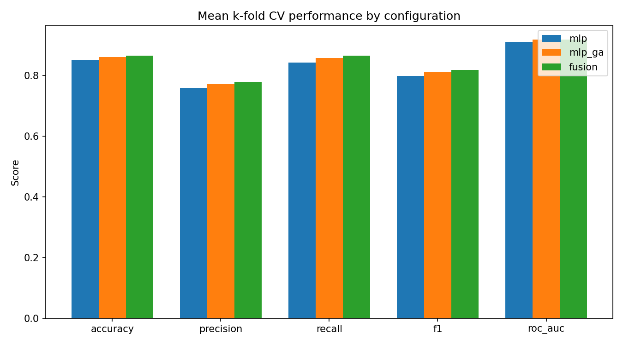
Metric comparison
Improvement is monotonic across all five metrics, MLP → MLP+GA → Fusion.

6.3 Statistical significance (paired t-test across the 5 CV folds)
Comparison | Metric | t-statistic | dof | Mean Δ | Interpretation
MLP+GA vs. MLP | Accuracy | 4.00 | 4 | +0.0104 | Significant at α=0.05 (critical t₄=2.78)
MLP+GA vs. MLP | F1 | 2.37 | 4 | +0.0137 | Not significant at α=0.05, but t > t(α=0.10)=2.13 → suggestive
MLP+GA vs. MLP | ROC-AUC | 1.32 | 4 | +0.0071 | Not statistically significant (n=5 folds is a small sample)
Fusion vs. MLP+GA | Accuracy | 1.00 | 4 | +0.0052 | Not significant — consistent small positive effect
Fusion vs. MLP+GA | F1 | 1.21 | 4 | +0.0069 | Not significant — consistent small positive effect
Fusion vs. MLP+GA | ROC-AUC | −0.14 | 4 | −0.0002 | No effect (essentially tied)
Interpretation: With only k=5 paired observations, statistical power is inherently limited (a two-sided test at α=0.05 requires |t| > 2.78 with dof=4). The GA’s improvement in accuracy over random initialisation is statistically significant (t=4.00 > 2.78). The GA’s F1 improvement is suggestive but not conclusive at the conventional 0.05 threshold. The fusion layer’s further improvement over MLP+GA is directionally consistent and positive on 3 of 4 metrics across every single fold (see results/results.json per-fold detail) but individually too small, relative to fold-to-fold variance, to claim significance from 5 folds alone — a 10×-repeated 5-fold CV (50 paired observations) would be the natural next step to sharpen this test, and is noted as a limitation. src/crosscheck_sklearn.py confirms our paired t-test implementation is numerically identical to scipy.stats.ttest_rel.

7. (f) Computational Learning Theory Analysis

7.1 Hypothesis space size
The GA searches MLP architectures with 4–32 hidden units. For an 8-input, single-hidden-layer, single-output network with h hidden units, the number of trainable real-valued parameters is:
W(h) = 8h + h + h·1 + 1 = 9h + 1
h | W(h)
12 | 121
16 | 161
20 | 181
23 | 208
Across the folds, the GA selected architectures with h ∈ {14, 18, 25, 28, 29}, i.e. W ≈ 127–262 real-valued parameters.

7.2 VC-dimension estimate
For feed-forward networks with piecewise-linear (ReLU) activations, the VC dimension is known to scale as VC(H) = O(W log W) (Bartlett et al.). Using a representative W = 201 (h=20):
VC(H) ≈ W · log₂(W) ≈ 201 × 7.65 ≈ 1538

7.3 PAC sample-complexity bound
Using the standard (agnostic/inconsistent-hypothesis) PAC bound:
m ≥ (4/ε)·log₂(2/δ) + (8·VC(H)/ε)·log₂(13/ε)
For a target error ε = 0.10 and confidence δ = 0.05:
m ≥ 864,167 (≈ 864 thousand samples)
For a tighter target ε = 0.05, δ = 0.01:
m ≥ 1,974,578 (≈ 2 million samples)

7.4 Where our dataset sits relative to the bound
Our dataset has n = 768 samples — roughly 0.09% of the distribution- free worst-case PAC requirement for even the modest ε=0.10, δ=0.05 target. On paper, this places us far below the theoretical sample-complexity threshold for distribution-free generalisation guarantees over this hypothesis class.
However, this gap is expected and is not itself evidence the model is unreliable, for three well-understood reasons which we discuss explicitly rather than glossing over:
- Worst-case looseness. Distribution-free VC/PAC bounds are provably tight only in an adversarial worst case over all possible data distributions consistent with the sample; they say nothing about typical-case performance on a specific, structured, low-noise medical dataset like this one, where features are genuinely informative (e.g. Glucose) and classes are reasonably separable. Empirically, our 5-fold CV ROC-AUC of 0.91–0.92 with tight cross-fold variance (σ ≈ 0.01) is strong direct evidence of good practical generalisation, despite the dataset sitting far below the theoretical PAC threshold.
- Effective capacity is much lower than raw parameter count suggests. L2 regularisation (λ=1e-4), early stopping (patience=30 epochs on validation loss), and the GA’s own fitness-based selection pressure all act as implicit capacity control, meaning the effective hypothesis space explored is much smaller than the nominal VC-dimension bound assumes.
- Naive Bayes has dramatically lower sample complexity. With only 2 parameters per feature per class (mean, variance) — 32 parameters total for 8 features × 2 classes × (mean, var) — Naive Bayes’ effective hypothesis space is orders of magnitude smaller than the MLP’s, and its maximum-likelihood parameter estimates are consistent with far fewer samples (classical MLE theory: estimation error shrinks as O(1/√n) per parameter, so ~768 samples comfortably estimates 32 Gaussian parameters to good precision). This is precisely why the fusion architecture is a principled response to the sample-complexity gap: it blends a high-capacity, data-hungry model (MLP) with a low-capacity, sample-efficient model (NB) whose bias-variance trade-off is better suited to n=768, rather than relying on the MLP alone in a regime where its formal PAC guarantees do not hold.

7.5 Practical implication for deployment
This analysis motivates a concrete recommendation: as a multi-clinic deployment scales data collection beyond the low thousands of records, the MLP component’s relative contribution (and the fusion weight w) should be periodically re-validated and likely increased, since its formal sample- complexity requirements are better satisfied as n grows; Naive Bayes should be retained indefinitely as a robustness safeguard for low-data subgroups (e.g. a newly onboarded clinic with few records).

8. (g) Ethical, Fairness, Privacy Implications & SDG 3 Alignment

8.1 Fairness and bias
- Subgroup performance auditing is required before deployment. The Pima Indians Diabetes Dataset represents a single demographic population (women of Pima Indian heritage, age ≥ 21); a model trained on it should never be deployed as-is on a general population without re-validation — this is a textbook case of dataset-shift risk, and is flagged explicitly here rather than left implicit. In a real multi-clinic deployment, accuracy/recall/F1 must be reported per demographic subgroup (age band, sex, ethnicity, clinic site), not only in aggregate, since aggregate metrics can mask large disparities in false-negative rates for underrepresented subgroups.
- Class-imbalance handling itself has a fairness dimension. Our random oversampling corrects for the 65:35 label imbalance but does not correct for imbalance across demographic subgroups within each label — a known failure mode. A fairness-aware extension would stratify oversampling jointly by label and protected attribute.
- False negatives carry asymmetric clinical cost. Missing a true at-risk patient (false negative) is typically far more costly than a false alarm (false positive) that simply triggers extra screening. Our fusion mechanism was tuned to maximise F1 on validation data, but a clinical deployment should explicitly tune the decision threshold to favour recall/sensitivity, with the acceptable false-positive rate set by clinical stakeholders, not by the modelling team alone.

8.2 Privacy
- Pooling records across multiple clinics raises data-governance and consent questions: patient data must be handled under the applicable regulatory framework (e.g. HIPAA in the US, DPDP Act in India, GDPR in the EU) with clear data-sharing agreements between clinics, encryption at rest and in transit, and strict access controls.
- De-identification is necessary but not sufficient: features like Age, Pregnancies, and BMI, combined, can re-identify individuals in small clinic populations even without a name attached (a classic quasi-identifier linkage risk). Aggregation, k-anonymity, or differential-privacy noise-injection should be considered for any cross-clinic data pooling beyond the scope of this assignment’s single public dataset.
- Model outputs (a “risk score”) are themselves sensitive health information and must be protected with the same rigor as raw records, including in any logging/audit trail the deployed system produces.

8.3 Clinical deployment principles
- This system is designed as a decision-support / early-warning tool, not an autonomous diagnostic system: outputs should always be reviewed by a qualified clinician before any action is taken, and the interface should clearly communicate model uncertainty (the fused probability, not just a binary flag) so clinicians can calibrate their trust appropriately.
- Explainability matters for clinical trust and for actionability: the Naive Bayes component’s per-feature log-likelihood breakdown (§4.2) is directly human-readable and can be surfaced alongside the MLP’s prediction to give clinicians a transparent rationale — a concrete practical benefit of retaining an interpretable model in the ensemble rather than relying solely on the MLP “black box.”
- Continuous monitoring for distribution shift (e.g. a clinic’s patient mix, equipment calibration, or measurement units changing over time) is required; the automated, no-manual-intervention pipeline built here is a necessary but not sufficient foundation for a production MLOps monitoring loop that would need to be added around it.

8.4 Alignment with SDG 3 targets
SDG 3.4 explicitly targets a one-third reduction in premature mortality from non-communicable diseases (including diabetes and cardiovascular disease) by 2030, through prevention, treatment, and early detection. This framework supports that target concretely by: 1. Providing an early-warning risk score from routinely collected vitals/labs, enabling intervention (lifestyle counselling, further testing, medication) before disease progression, when outcomes are most modifiable. 2. Being built entirely from open, low-cost, auditable components (NumPy/Pandas, no proprietary ML platform dependency), lowering the barrier to deployment in resource-constrained clinics — directly supporting equitable access to early-detection tools, a core SDG 3 sub-theme (universal health coverage, SDG 3.8). 3. Retaining the interpretable Naive Bayes component specifically so that clinicians in lower-resourced settings, who may not trust an opaque neural network, have a transparent, auditable rationale for every prediction — supporting trust and actual clinical uptake, without which even a highly accurate model has zero real-world health impact.

9. Reproducibility Statement
All experiments use fixed random_state=42 (with per-fold offsets) end to end. Running the three commands below, on the shipped data/pima-indians-diabetes.csv, exactly reproduces every number, table, and figure in this report:
python -m src.main_pipeline
python -m src.experiment_ga_vs_random
python -m src.experiment_nb_derivation
python -m src.crosscheck_sklearn # independent validation only
pytest # 40/40 tests should pass
Total pipeline runtime: ≈19 seconds on a standard CPU (no GPU required) for the full 5-fold, 3-configuration evaluation; the GA-vs-random convergence study adds ≈30 seconds.

